Chapter 2 Getting Started

1. Unix systems provide two special files that are particularly useful in shell programming.
2. The first file, /dev/null. Data sent to this file is thrown away by the system. In other words, a program writing data to this file always believes that it has successfully written the data, but in practice, nothing is done with it.

For example, to test if a file contains a pattern:

if grep pattern myfile > /dev/null

then

... *Pattern is there*

else

... *Pattern is not there*

In contrast to writes, reading from /dev/null always returns end-of-file immediately.

1. The second file, /dev/tty. When a program opens this file, Unix automatically redirects it to the real terminal.

Chapter 3 Searching and Substitutions

1. Within bracket expressions, all other metacharacters lose their special meanings. Thus, [\*\.] matches a literal asterisk, a literal backslash, or a literal period.
2. To get a ] into the set, place it first in the list: [ ]\*\.] adds the ] to the list. To get a minus character into the set, place it first in the list: [-\*\.]. If you need both a right bracket and a minus, make the right bracket the first character, and make the minus the last one in the list: [ ]\*\.-].
3. BRE operator precedence

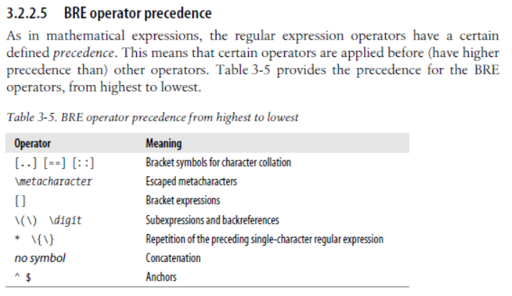

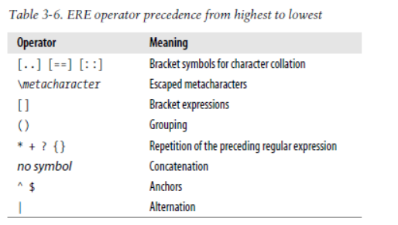

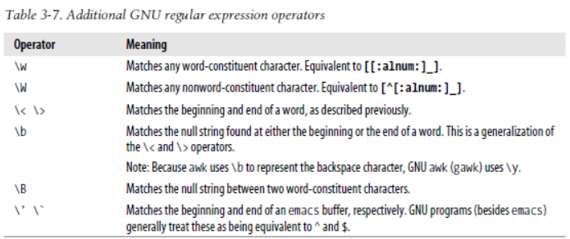

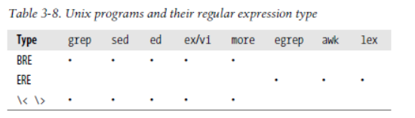

By default, POSIX grep uses BREs. With the –E option, it uses EREs, and with the –F option, it uses the fgrep fixed-string matching algorithm.

1. Most of the time, the right program to use for text substitutions is sed, the Stream Editor. sed is designed to edit files in a batch fashion, rather than interactively.

2016-05-29

1. Command: cut

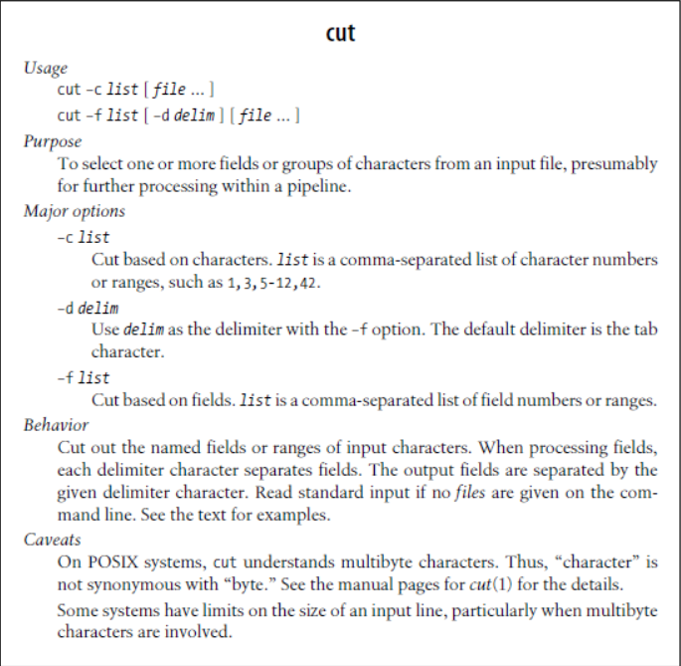

1. Command: join

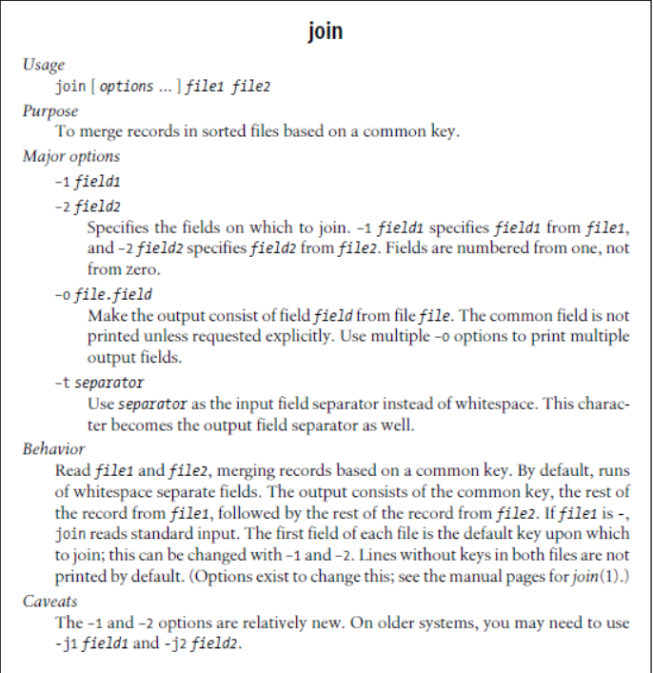

1. awk is often used for simple one-liners, where it’s necessary to just print selected fields, or rearrange the order of fields within a line. Since it’s a programming language, you have much more power, flexibility, and control, even in small programs.

2016-05-30

Chapter 4 Text Processing Tools

1. Command: sort

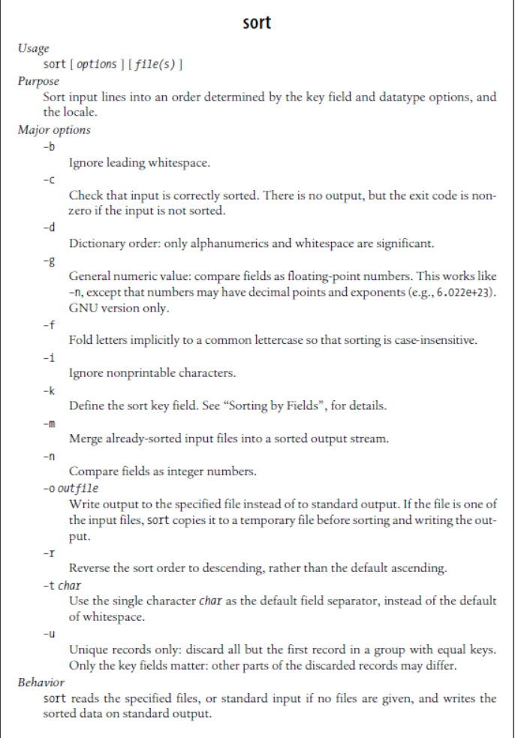

If a comma-separated pair of field numbers is given, the sort key starts at the beginning of the first field, and finishes at the end of the second field. With a dotted character position, comparison begins (first of a number pair) or ends (second of a number pair) at that character position: –k2.4,5.6 compares starting with the fourth character of the second field and ending with the sixth character of the fifth field.

1. When multiple –k options are given, sorting is by the first key field, and then, when records match in that key, by the second key field, and so on.

2016-06-03

2016-06-04

1. Other commands: 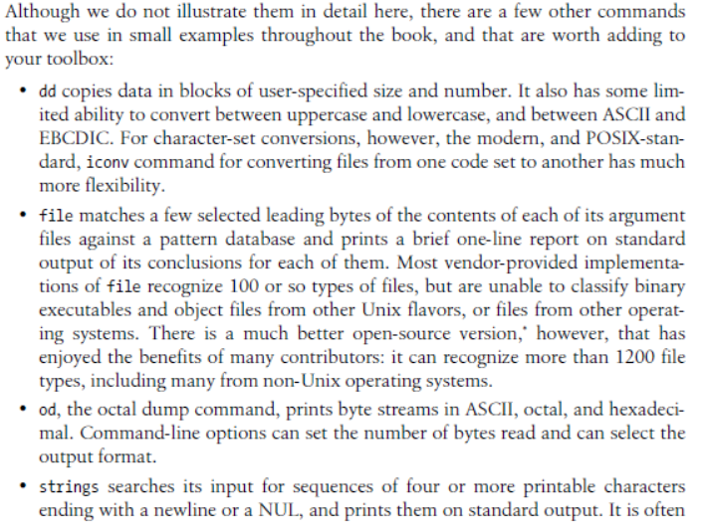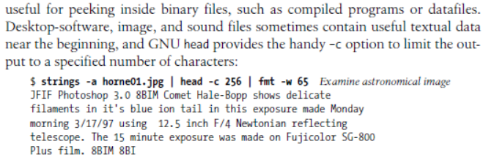

2016-06-05

Chapter 5 Pipelines Can Do Amazing Things

1. Command: du

Estimate file space usage.

du -s

2016-06-06

Chapter 6 Variables, Making Decisions, and Repeating Actions

1. Command: readonly and export

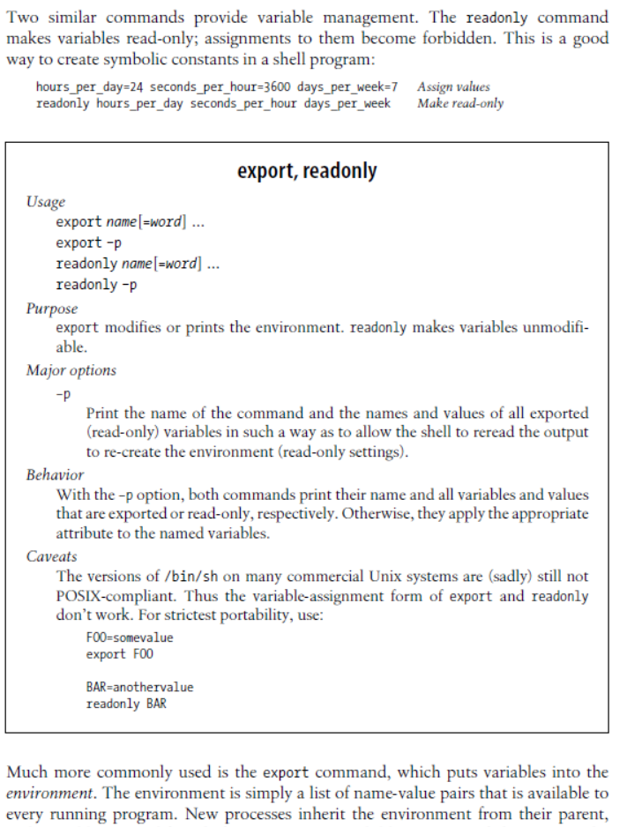

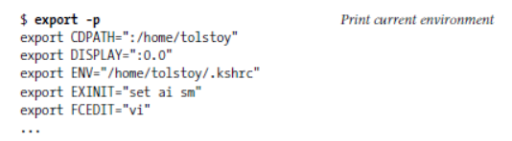

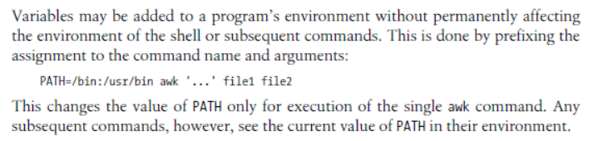

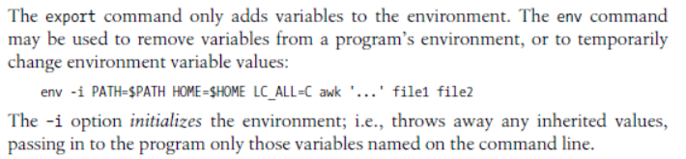

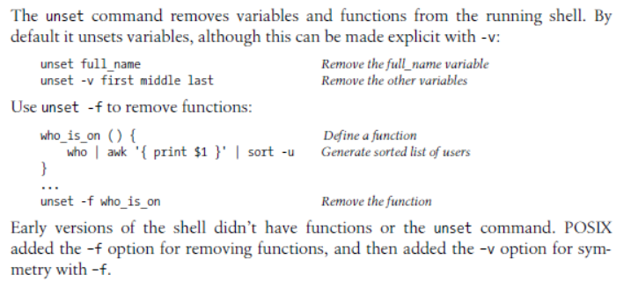

1. 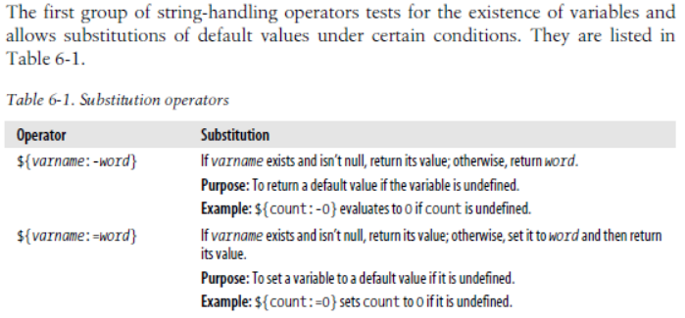
2. 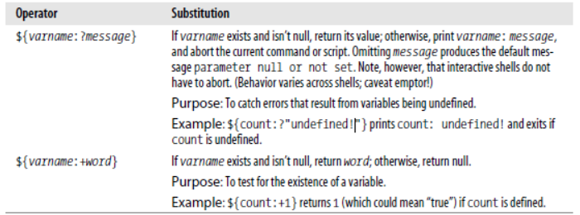
3. 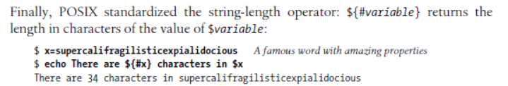
4. 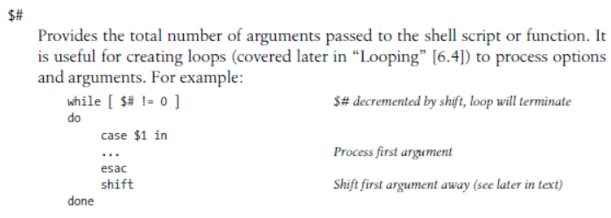

2016-06-07 (高考十周年 ☺ )

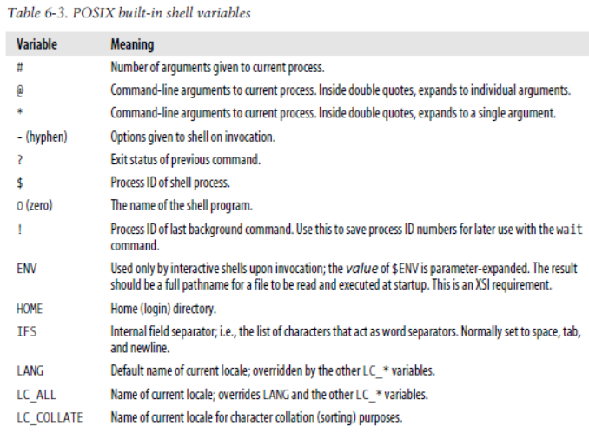

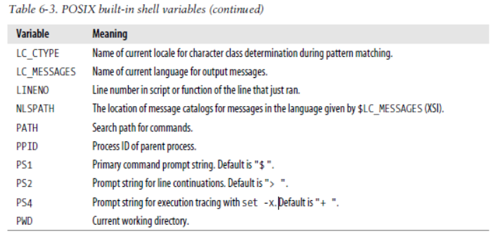

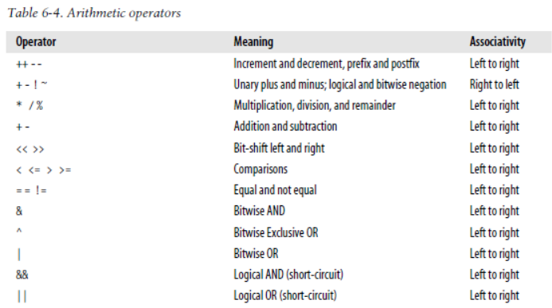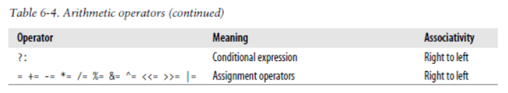

Command: echo $? Getting the exit status of the previous command

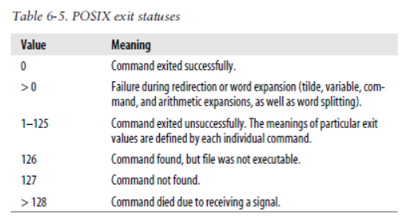

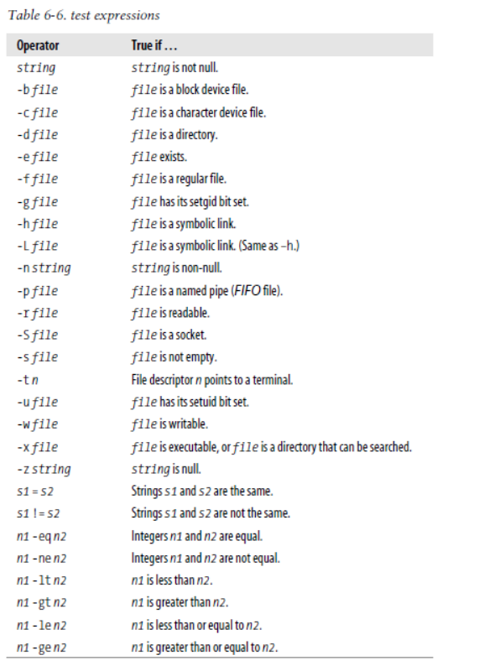

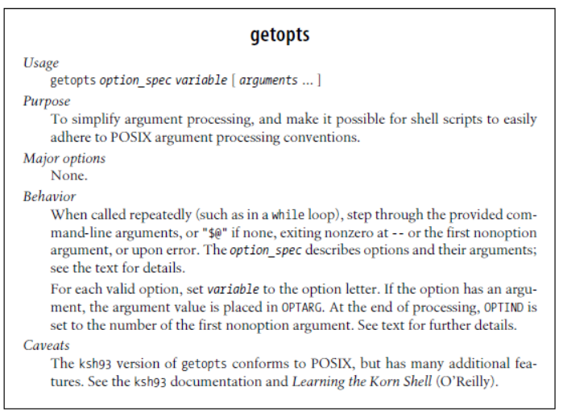

2016-06-08

Chapter 7 Input and Output, Files, and Command Evaluation

1. Command: Read

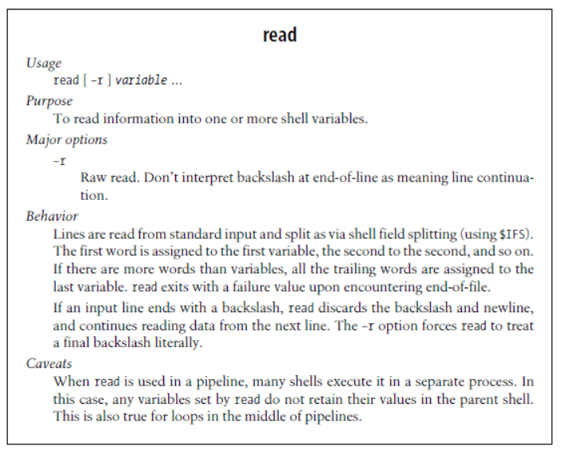

2016-06-09

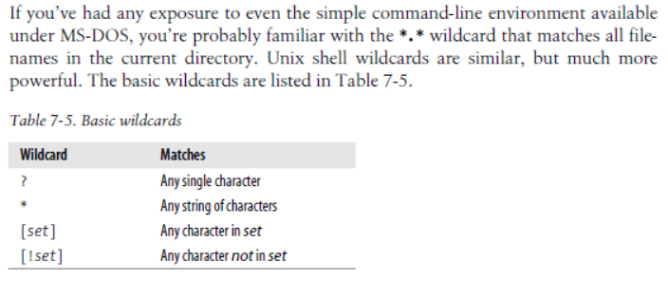

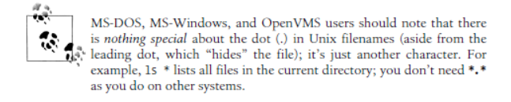

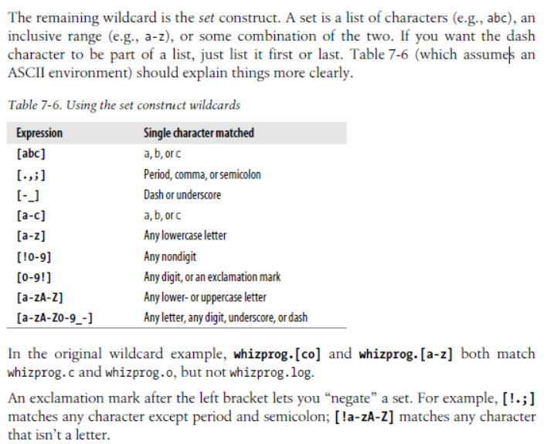

1. Command: sa
2. 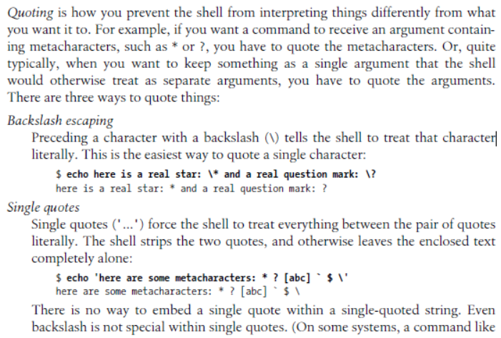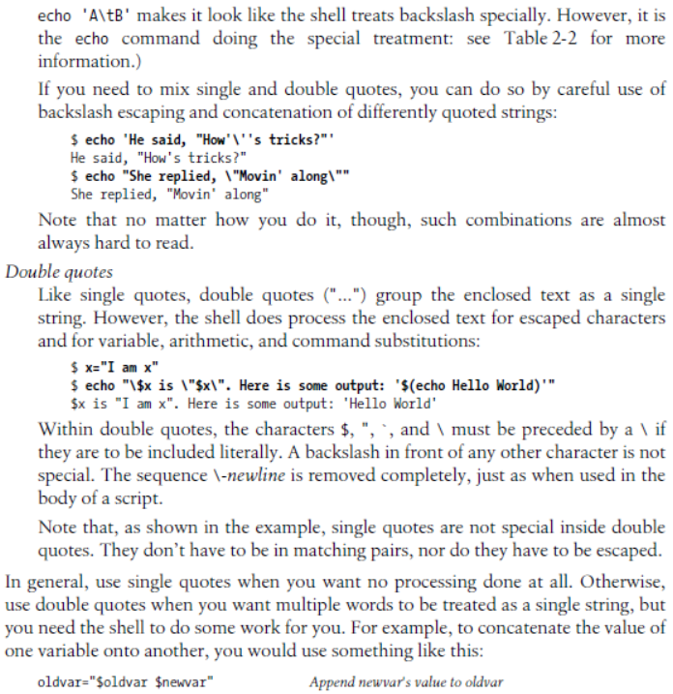

2016-06-11

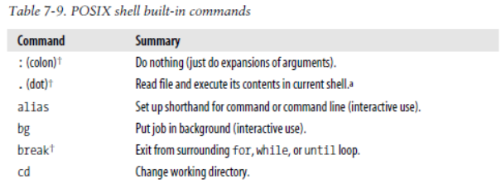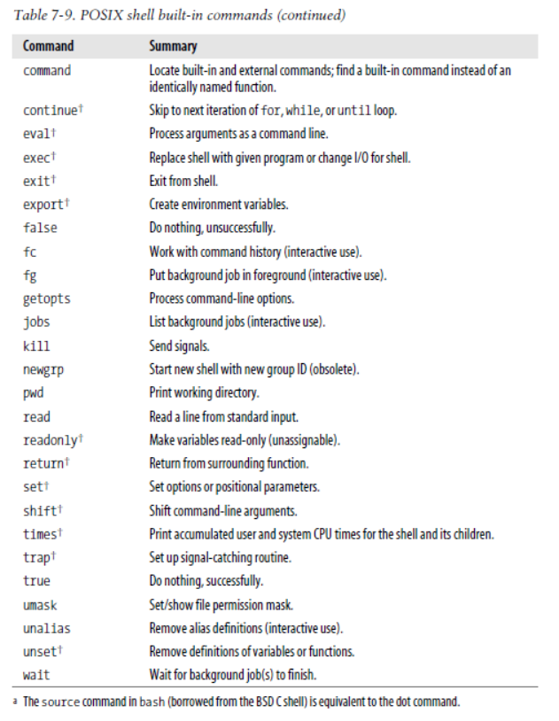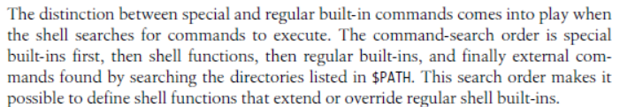



Chapter 8 Production Scripts

1. 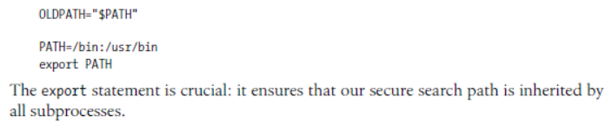
2. Command: basename

2016-06-12